1.Distribution of Aggregate Ratings
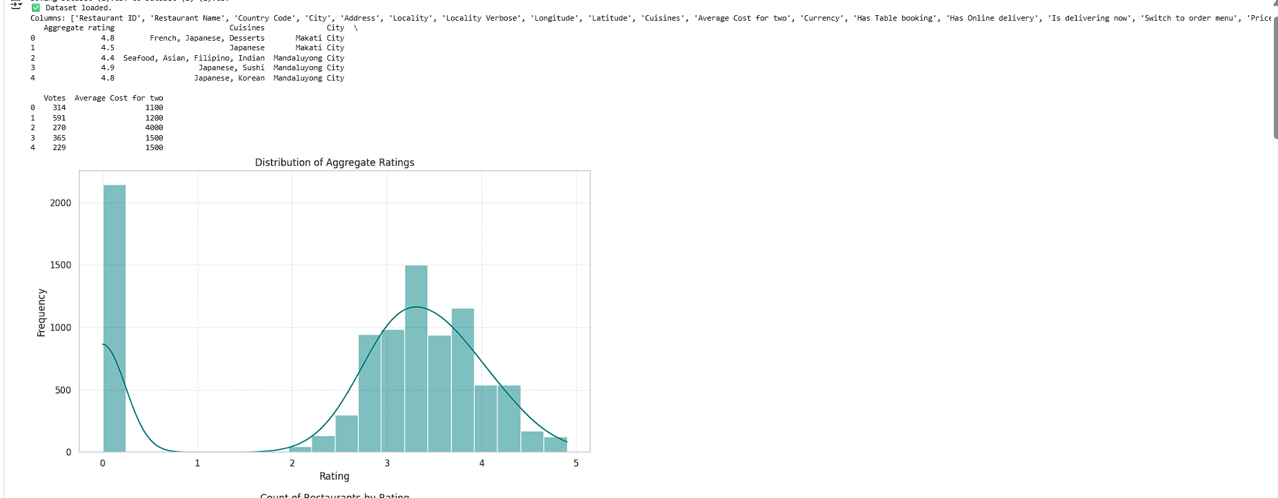

2. Count of Restaurants by Rating

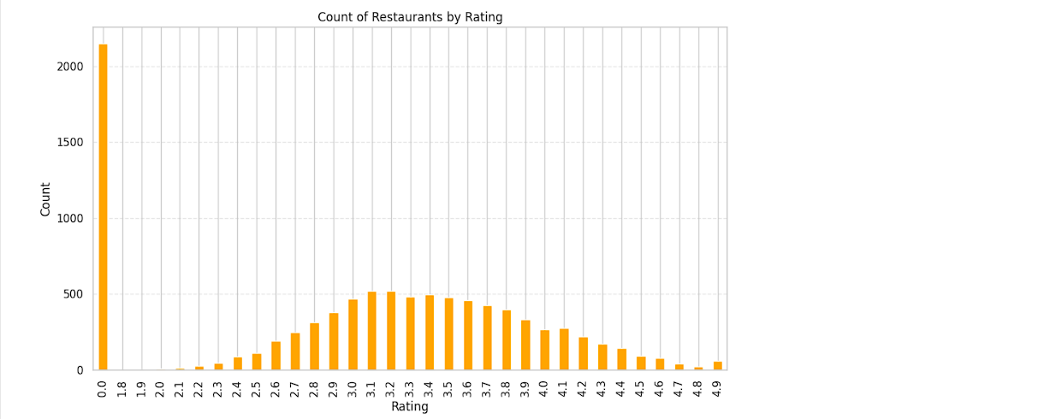

3. Top 15 Cuisines by Average Rating
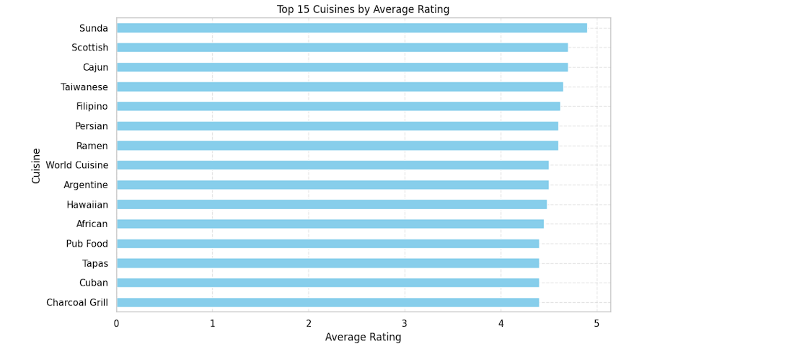

4. Top 15 Cities by Average Restaurant Rating
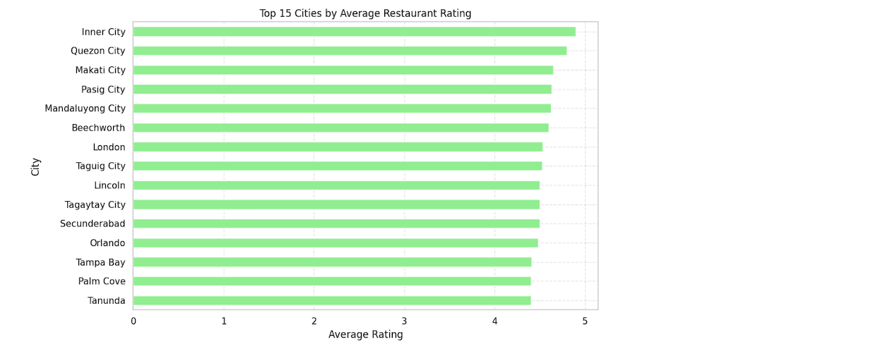

5. Votes vs Aggregate Rating
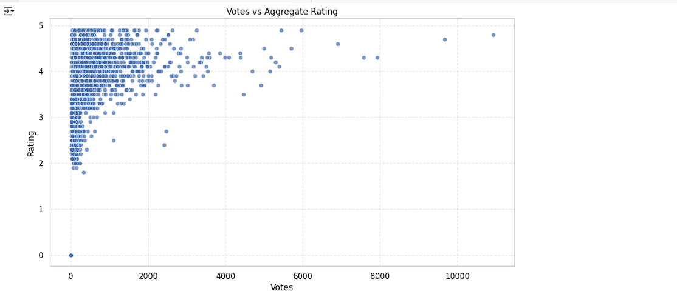

6. Cost for Two vs Aggregate Rating
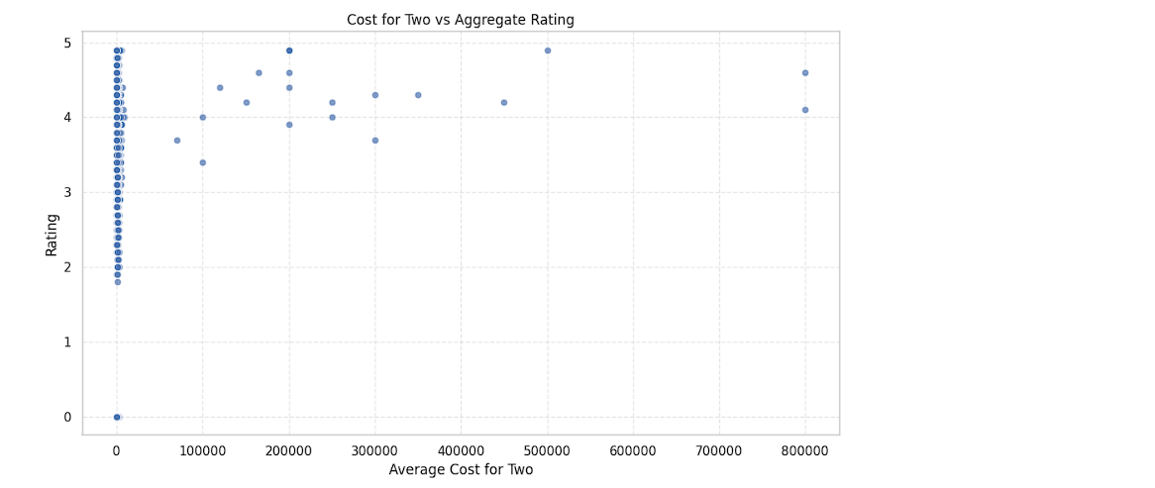

7. Correlation Heatmap
